1. Write a SQL query to find first and last names of all employees whose first name starts with “Sa” (case insensitively). Order the information by id. Submit your query statements as Prepare DB & run queries.

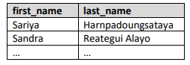

1. Write a SQL query to find first and last names of all employees whose last name contains “ei” (case insensitively). Order the information by id. Submit your query statements as Prepare DB & run queries.

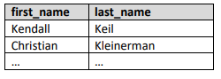

1. Write a SQL query to find the first names of all employees in the departments with ID 3 or 10 and whose hire year is between 1995 and 2005 inclusively. Order the information by id. Submit your query statements as Prepare DB & run queries

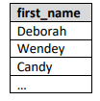

1. Write a SQL query to find the first and last names of all employees whose job titles does not contain “engineer”. Order the information by id. Submit your query statements as Prepare DB & run queries.

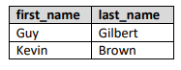

1. Write a SQL query to find town names that are 5 or 6 symbols long and order them alphabetically by town name. Submit your query statements as Prepare DB & run queries.

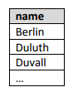

1. Write a SQL query to find all towns that start with letters M, K, B or E (case insensitively). Order them alphabetically by town name. Submit your query statements as Prepare DB & run queries.

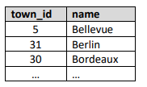

1. Write a SQL query to find all towns that do not start with letters R, B or D (case insensitively). Order them alphabetically by name. Submit your query statements as Prepare DB & run queries.

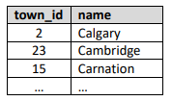

1. Write a SQL query to create view v_employees_hired_after_2000 with the first and the last name of all employees hired after 2000 year. Submit your query statements as Run skeleton, run queries & check DB.

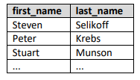

1. Write a SQL query to find the names of all employees whose last name is exactly 5 characters long.

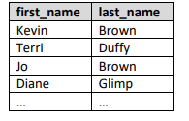

1. Find all countries that hold the letter 'A' in their name at least 3 times (case insensitively), sorted by ISO code. Display the country name and the ISO code. Submit your query statements as Prepare DB & run queries.

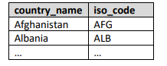

1. Combine all peak names with all river names, so that the last letter of each peak name is the same as the first letter of its corresponding river name. Display the peak name, the river name, and the obtained mix. Sort the results by the obtained mix alphabetically. Submit your query statements as Prepare DB & run queries.

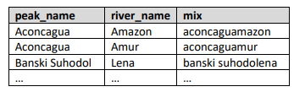

1. Find the top 50 games ordered by start date, then by name. Display only the games from the years 2011 and 2012. Display the start date in the format “YYYY-MM-DD”. Submit your query statements as Prepare DB & run queries.

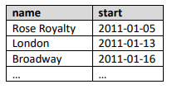

1. Find information about the email providers of all users. Display the user_name and the email provider. Sort the results by email provider alphabetically, then by username. Submit your query statements as Prepare DB & run queries.

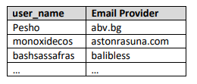

1. Find the user_name and the ip_address for each user, sorted by user_name alphabetically. Display only the rows, where the ip_address matches the pattern: “___.1%.%.___”. Submit your query statements as Prepare DB & run queries.

